**Meshack Nyagwencha Bosire**

**Neptun code: IVF370**

4.1.

A) What modes do we have to configure on each network adapter?

Root privilege or super user mode

B) What command the IP addresses can be configured with?

sudo ifconfig eth0 <ip addr> netmask <netmask>

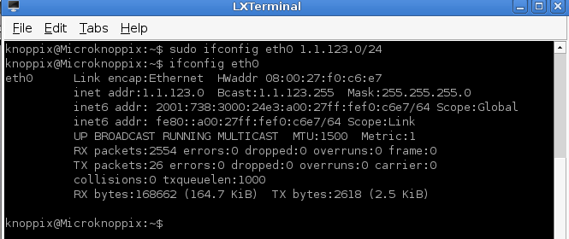

4.2.

A) What is the meaning of the routing table?

A routing table serves as a database that tracks paths, and assists determine the best optimal way to forward network traffic.

B) What command the access of a direct network can be configured with?

route add –net <ip addr> eth0

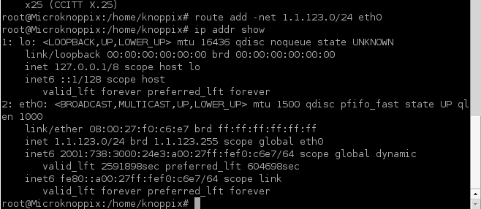

C) What command can the access of a remote network be configured with?

route add –net <ip addr> gw

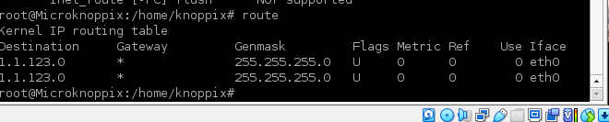

4.3.

A) How can we find the number of routers between two nodes? Determine the command.

Traceroute

The traceroute command will return the names or IP addresses of all the routers between two devices.

Ping –c 4 unideb.hu

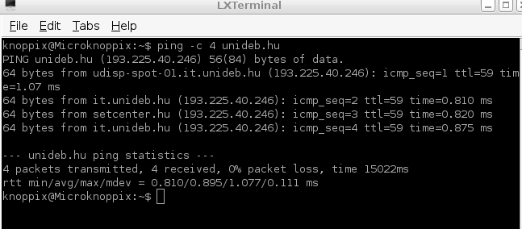

Common default ttl value in linux is 64

Number of router is (64 – ttl value) = 64 -59 = 5

B) What does RTT (Round-Trip Time) value prove?

Round Trip Time (RTT) is the time it takes to get a response after initiating a network request.